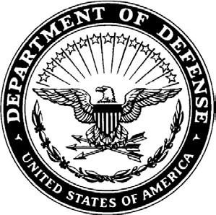
NGGA-PEA 7 October 2025

MEMORANDUM THRU

Commander, Click or tap here to enter text.

Commander, Click or tap here to enter text.

MEMORANDUM FOR The Adjutant General of Georgia, Georgia Department of Defense, 1000 Halsey Ave SE, Bldg. 447, Marietta, GA 30060

SUBJECT: Recommendation for Promotion of Click or tap here to enter text.

1. Under the provisions of Chapter 8, NGR 600-100, I recommend the following named officer be promoted in the Army National Guard:

a. Name: Click or tap here to enter text.

b. DODID:Click or tap here to enter text.

c: Present Grade, Branch, AOC: Click or tap here to enter text.

d. Present Assignment: (UIC, Unit, Position Title, Grade, Position Number, PARA/LIN)
Click or tap here to enter text.

e. Assignment for which recommended: (UIC, Unit, Position Title, Grade, Position Number,
PARA/LIN)
Click or tap here to enter text.

f. Unit Mailing Address: Click or tap here to enter text.

g. Mailing address:Click or tap here to enter text.

2. This officer has clearly demonstrated the required fitness for the responsibilities and duties of the position, grade, and branch for which recommended.

a. The following periods of service are creditable for promotion to the higher grade.
Click or tap to enter a date. to Click or tap to enter a date.

b. The officer meets the minimum military and civilian educational requirements.
Military Education Level: Choose an item. Civilian Education Level: Choose an item.
Click or tap here to enter text.
Subject: Recommendation for Promotion of Click or tap here to enter text.

c. The verified physical fitness date is Click or tap to enter a date. and passing score is Click or tap here to enter text.

d. The individual meets the height and weight standards of AR 600-9.
Height: Weight:
Actual Body Fat Percentage: %, maximum allowable percentage %

e. The officer has a current PHA dated Click or tap to enter a date.and current MRC of Click or tap here to enter text.

3. Effective date of promotion is determined by the Federal Recognition order issued by National Guard Bureau. Individual will not wear the insignia of the grade to which promoted nor will they be paid in that grade until Federal Recognition is confirmed.

COMMANDER NAME
GRADE, BRANCH
Commanding

